
South Carolina Attorney General’s Office
South Carolina Crime Victim Services Division
Department of Crime Victim Compensation (DCVC)

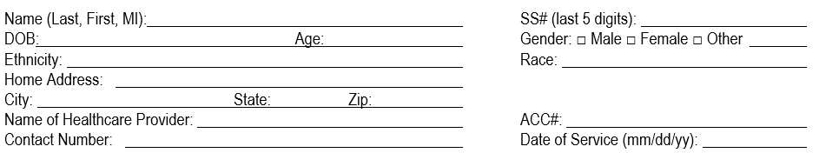
Sexual Assault Protocol (SAP) Billing Claim Form
Flat Fee: $875.00 Maximum Allowed Amount for Forensic Examination

󠄶 Physician, FNP, NP Fee $200.00 | 󠄶 SANE Fee $175.00 | 󠄶 ED Fee $200.00
󠄶 Colposcopy Fee $125.00 | 󠄶 Labs/Meds Fee $175.00 | 󠄶 VOUCHER FOR CDC MEDS PAID BY SCVAN
Flat Fee NKC – $475.00 Maximum Allowed For No Evidence Collected
󠄶 Physician, FNP, NP Fee $200.00 | 󠄶 SANE Fee $175.00 | 󠄶 Labs/Meds Fee $100.00
󠄶 VOUCHER FOR CDC MEDS PAID BY SCVAN

Other Med: After hours Rx given  Approval: Must send a copy of Walgreen Direct Bill with this Protocol  Signature: ________________________________________________  Internal Use: email to Rbrockman@scag.gov  ____________________________________________________________ | Total Amount Billed  $

Remittance Address Required  SCEIS #: | Health Care Provider must attach a copy of the Medical Examination Release Form to this Protocol Billing Claim Form for payment and forward to:  Department of Crime Victim Compensation (DCVC)  Edgar A. Brown Building, 1205 Pendleton Street, Room 401, Columbia, SC 29201  Telephone 803-734-1900 ● Facsimile 803-734-2261  Email Forms: SAP-Billing@scag.gov
